Creeping Bentgrass,
Agrostis stolonifera L.

Tom Cook

Associate Professor Emeritus
Oregon State University Horticulture Dept.

Introduction:

For as long as golf has been played in the Pacific Northwest creeping bentgrass has been planted on putting greens, first as a component of South German mixed bentgrass, and later as seeded or stolonized varieties. In recent year’s, intense breeding and selection work has resulted in a flood of new cultivars with widely varying characteristics and generally much improved surface quality. While early creeping bentgrasses quickly gave way to annual bluegrass, newer cultivars are much more competitive and may prove to be much more persistent.

Creeping bentgrass has been planted on fairways at a modest number of golf courses in the PNW. Though rarely planted in lawns, it has naturalized throughout much of the areas west of the Cascade Mountains and is one of the common species found in lawns throughout the Willamette valley, the Puget Sound, and in lower British Columbia. It is also found as a contaminant in lawns throughout areas east of the Cascades.

Taxonomy and History:

As with other bentgrasses, creeping bentgrass is thought to be a native of Western Europe. It most likely arrived in North America during colonization and was most likely introduced as a turfgrass in South German mixed bentgrass seed. Creeping bentgrass is an allotetraploid with 2n = 28. It is cross pollinated and also forms interspecific hybrids (6). Early literature refers to creeping bentgrass as Agrostis maritima Lam. (2). In the USA Hitchcock referred to it as A. palustris Huds. which he considered more stoloniferous than A. stolonifera L. (4). In recent years Agrostis stolonifera L. has become the accepted nomenclature (5,6).

Selections of superior types of creeping bentgrass from original plantings of South German mixed bentgrass led to development of the C series bentgrasses at the Arlington Turf Gardens in Virginia (6). For many years these vegetative strains were the best sources for bentgrass greens. Toronto (C 15) selected at Toronto Golf Club in Long Branch, Ontario, Canada and Old Orchard (C 52) selected at Old Orchard Grass Nursery in Madison, WI. (3) were vegetative strains widely used in the PNW. Toronto was used on many golf courses designed by Glen Proctor, Milt Bauman, and Roy Goss. Architects from outside of the PNW often used Old Orchard. Under our conditions Toronto was an outstanding putting green grass while Old Orchard had a very poor track record. Neither grass competed well with annual bluegrass.

Seaside creeping bentgrass was the only seed propagated creeping bentgrass available from the 1920’s until 1954 when Penncross was introduced. Seaside was originally discovered near Coos Bay, OR. Seaside was a relatively weak grower made up of numerous naturalized clones (6). Old Seaside greens looked like a patchwork quilt of colors and textures. Its strong suit was salt tolerance. There are no surviving Seaside greens in the Northwest as plantings were invariably rapidly invaded and replaced by annual bluegrass.

The first major breakthrough in creeping bentgrass came in 1954 with the release of Penncross by the Pennsylvania AES in University Park, PA (3). Developed by H.B. Musser, Penncross is the first generation seed from three vegetatively propagated clones allowed to randomly pollinate (6). Penncross was much more vigorous than Seaside, had better summer performance, and produced both good putting turf and good fairway turf. It quickly became the most widely planted creeping bentgrass in the world. It has been extensively used in the PNW. In areas east of the Cascades it provided a tight dense turf with a characteristic gray green to green brown color. It has been a strong thatch former when fertilized regularly. While more competitive than Seaside, most Penncross greens eventually convert to annual bluegrass. West of the Cascades, Penncross tends to be fairly leafy and prone to thatch. It is slow growing in spring and competes poorly with annual bluegrass, partly due to the regular coring and vertical mowing required for managing thatch and reducing grain.

During the Penncross era, the only other seeded creeping bentgrass widely used in the PNW was Emerald which was released in 1965 (1). It was developed in Sweden from Congressional bentgrass (C 19). Emerald is a beautiful almost apple green grass that is very leafy. In areas west of the Cascades, it lacks vigor and is quickly dominated by annual bluegrass. Some superintendents actually use it as a nurse grass to encourage rapid conversion to annual bluegrass on remodeled greens. The only other creeping bentgrass used to any extent in the PNW prior to the latest generation of new grasses is Penneagle released in 1978 by the Pennsylvania AES (1). Under Northwest conditions Penneagle performs poorly on putting greens due to lack of vigor and is most often used on tees.

The next significant improvement in creeping bentgrass started with the introduction of Pennlinks (1986), SR 1020 (1987), and Providence (1988) (1). These were followed by Cobra, Crenshaw, National, Putter, Regent, Southshore, and Viper among others (6). Of these, Pennlinks and Providence probably have been most widely used. Most of these grasses produce better color and tighter denser turf than Penncross. Persistence and competitive ability are somewhat better than Penncross but these cultivars rarely resist annual bluegrass encroachment more than 10 years.

The latest round of breeding has produced the A, G, and L grasses. A-4 which is a recent release from the Pennsylvania AES has become very popular nationwide and is characterized by dense fine textured turf that is relatively resistant to annual bluegrass encroachment. Numerous new courses in the PNW have planted A-4 on putting greens. Century is another new creeping bentgrass that compares favorably with A-4. It has performed well in research trials at Washington State and at several golf courses in the Puget Sound area. It is too soon to judge how well these grasses will hold up over time.

Botanical Characteristics:

Creeping bentgrass is a stoloniferous cool season grass. On putting greens and other short cut turf, creeping bentgrass produces a dense prostrate growing stand. Texture varies from somewhat coarse to very fine (fig 1). Creeping bentgrass produces its best color during summer. During winter some cultivars turn off color or develop numerous purple clones giving greens a mottled look.

Fig 1. Comparison of Penncross generation texture and newer
generation creeping bentgrasses.
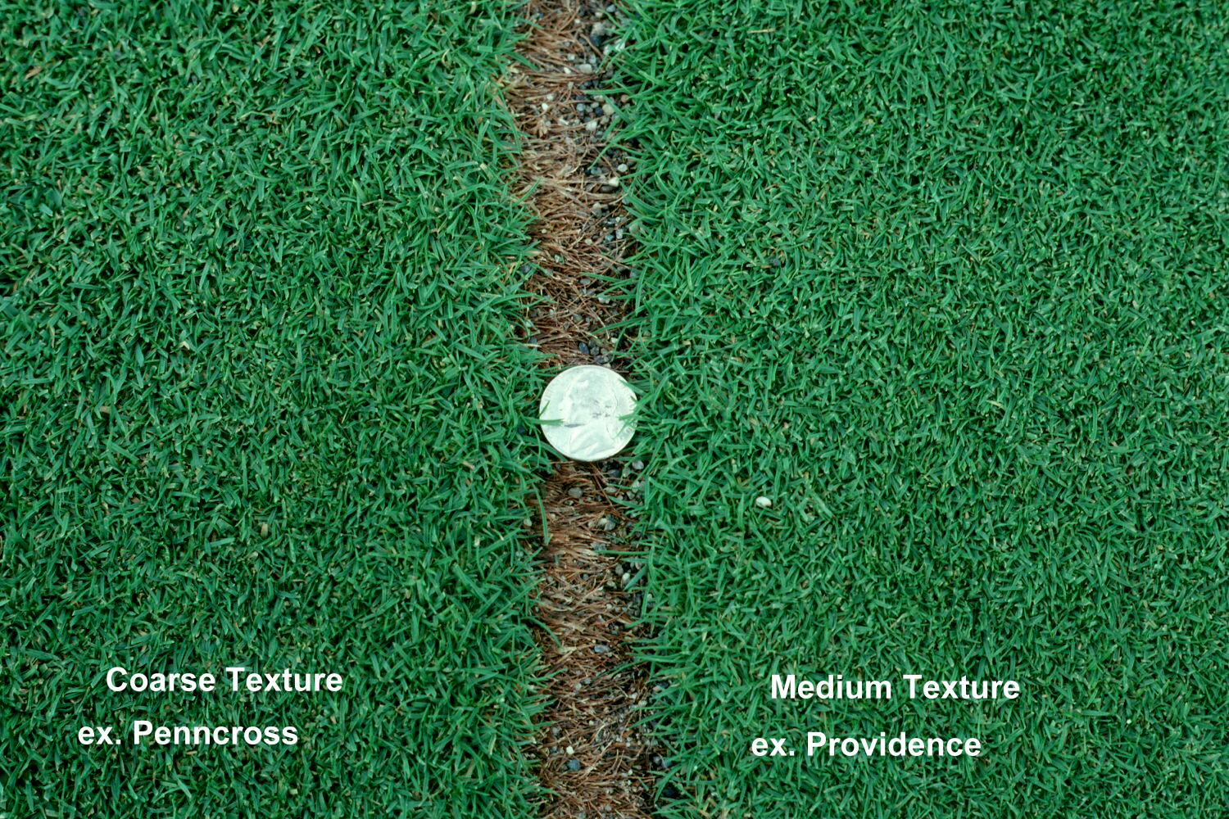

Vernation: New shoots are rolled.

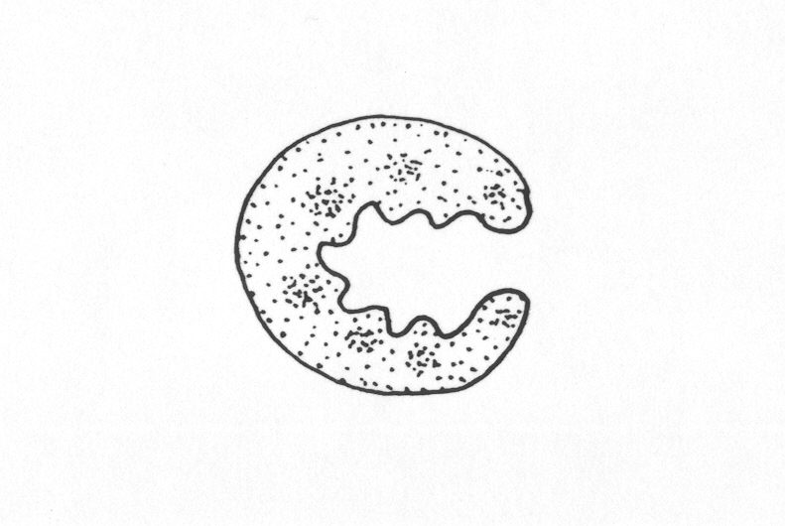
Leaf Characteristics:
Leaves are distinctly ridged on top.

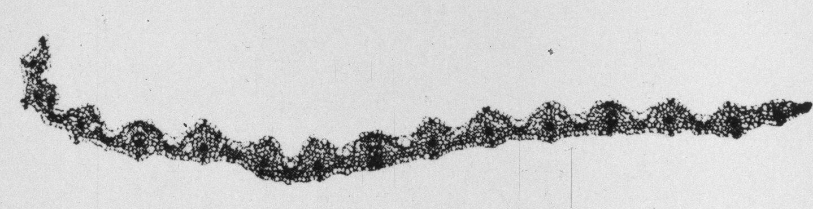

Leaf tips are pointed.

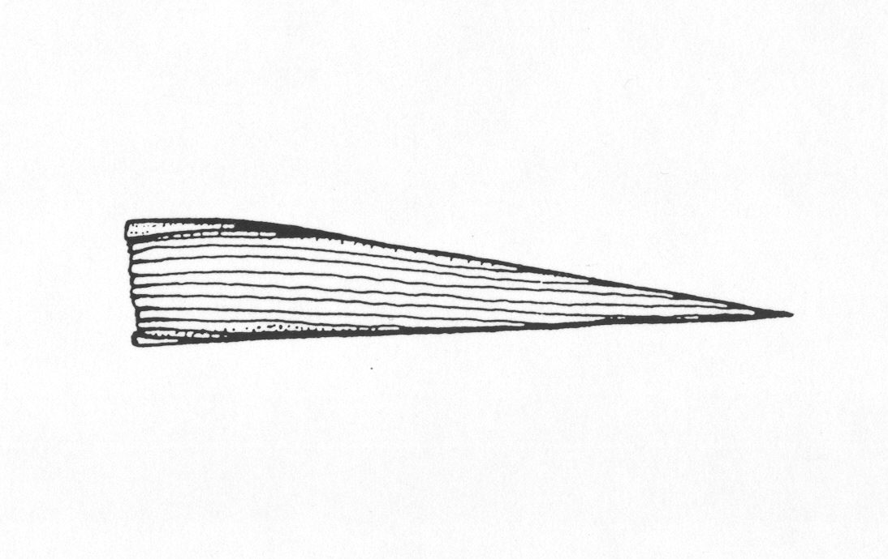

Ligule: Creeping bentgrass usually has a long ligule that is pointed or feathery at the tip.

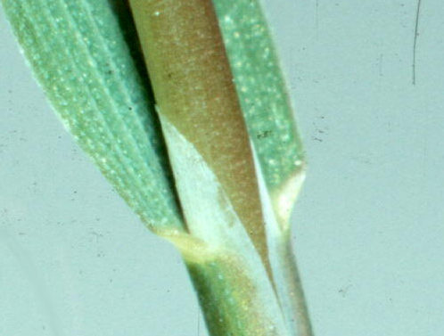

Auricles: Absent

Other: Creeping bentgrass stolons often show red coloration at the base of the sheath

Mowing:

Creeping bentgrass is best suited to bench setting heights between 0.5” and 0.125”. At higher mowing heights it gets puffy and develops false crowns. Below 0.125 it is not able to maintain density and compete over the long term with annual bluegrass. From a competitive standpoint, creeping bentgrass is probably at its best between 0.250” and 0.188”. These are heights none of us have seen for many years. The extreme low mowing heights used at many clubs today guarantee that greens will convert to annual bluegrass sooner rather than later. The newer super dense and super fine creepers appear to be more competitive at very low heights but we have too little experience to say with certainty that they will exclude annual bluegrass in the long run.

Thatch:

All vigorous creeping bentgrasses are strong thatch formers. On sand based greens, thatch can easily accumulate as much as 0.5” per year. Thatch build up is largely due to stolon development and the slow decomposition rate of thatch in a sand rootzone.

Thatch management is critical for long term performance of bentgrass greens. Our primary tools include twice yearly coring, periodic vertical mowing, dethatching with greens grade dethatchers, and regular topdressing with sand. Light frequent topdressing at intervals and rates designed to match growth are vital for maintaining firm surfaces and avoiding layers of thatch sandwiched between sand. Practically speaking the same strategies are needed to maintain functional creeping bentgrass fairways in western parts of the PNW because of the long growing season and tendency to generate thatch rapidly.

Failure to manage thatch aggressively may lead to soft surfaces, shallow rooting, reduced water flow into the turf, surface sealing, poor drainage, and black layer. Unfortunately, attempts to manage thatch open up the turf to encroachment by annual bluegrass.

Fertility:

Like other bentgrasses, creeping bentgrass requires little fertilizer when planted on mineral soils. One to three lb. N/1000 sq ft per year on soil will produce acceptable quality turf. On sand rootzones higher annual levels of N are needed. Optimum N fertility for creeping bentgrass on sand is probably 4-6 lb N/1000 +/-. Under lower N regimes, which are common on most golf courses, moss becomes a serious problem. This is commonly combatted with regular iron applications. Optimum N-P2O5-K2O-S ratios appear to be in the range of 6-1-4-4. The pH zone for creeping bentgrass ranges from 5 to 6.5 under Northwest conditions. Bentgrass is capable of growing even in high pH soils. While Phosphorus requirements are low it is possible to develop P deficiency on sand based rootzones receiving no supplemental P.

Irrigation:

Creeping bentgrass has no special irrigation requirements. The most common strategy used on golf courses involves frequent irrigation at slightly less than ET, supplemented with hand watering to maintain dry firm conditions during the growing season.

Diseases:

Creeping bentgrass gets its share of diseases. Nationwide Dollarspot, Brown Patch, and Pythium are important problems. Ironically, none of those cause serious problems in the PNW. The most common problems we see include Take All Patch, Microdochium Patch, Gray Snowmold, Yellow Patch, and sporadically bentgrass Leaf Blight (Red Leaf Spot). Under low fertility Red Thread can cause minor damage. Fairy Ring is also common on sand based greens, but that has less to do with bentgrass than with the thatch and root environment.

Young bentgrass growing in sand is likely to struggle with Take All Patch for the first 3-5 years after planting. Microdochium Patch is common primarily on shady greens or greens subject to long dew periods during fall and winter. In sunny locations on well drained greens, many of the newer cultivars are surprisingly resistant to Microdochium. Gray Snowmold is common wherever prolonged snow cover occurs. While there are apparent differences in resistance to this disease among cultivars, none are resistant enough to allow us to forgo fungicide treatments in late fall. Yellow Patch is quite common on newer bentgrass cultivars though it does not appear to cause more than cosmetic damage.

Fertility management has a significant impact on both Take All Patch and Microdochium Patch. Balanced NPK and supplemental sulfur can drastically reduce incidence of both diseases on creeping bentgrass. At annual rates of 3-4 lb S/1000 sq ft both diseases are often controlled almost completely.

Insects:

There are no special insect problems on bentgrass. The normal compliment of Black cutworm and European Crane fly are the most common problems. Cutworms are the insect most likely to be treated in a normal year on a putting green regardless of the type of grass growing on the green. Crane fly damage is less common on putting greens but we do see occasional damage. Crane fly is more likely to cause damage on bentgrass fairways or tees.

Cold and Heat tolerance:

Creeping bentgrass has always shown outstanding freezing tolerance and is probably the most cold tolerant cool season grass. In areas with cold open winters it is frequently killed or injured due to the combination of cold and desiccation. Creeping bentgrass normally hardens off in late fall and turns either brown or reddish brown as it becomes dormant. In milder climates it maintains its basic color but may develop numerous red clones giving it a mottled appearance. Weaker cultivars tend to thin out in winter which facilitates annual bluegrass encroachment.

Much of the breeding work in the last three decades has been directed at developing bentgrasses that tolerate prolonged high temperature stress. Improved heat tolerance would allow golf courses farther south to have bentgrass greens and enjoy year around the superior putting quality bentgrass provides. By and large the breeders have definitely improved heat tolerance. Functionally, that means very little to us in the Northwest because we don’t consistently see the heat loads typical of the arid Southwest or even the lower mid-West. Fortunately, there are more bentgrasses in the market place which gives us more options in selecting cultivars.

Shade:

Relatively speaking, creeping bentgrass grows fairly well in shade. Unfortunately, at putting green heights all cultivars are more prone to diseases and tend to be thin with weak root systems. The difference between creeping bentgrass growing in sun versus shade is very clear. Shaded bentgrass greens are destined to convert to annual bluegrass after struggling to produce functional turf.

Wear:

In wear trials bentgrass doesn’t hold up well compared to most other grasses. Wear from foot and vehicular traffic can cause severe thinning. For the most part, fortunately, concentrated wear is not a problem on most putting greens, tees, or even fairways. Wear damage is usually associated with young turf that has juvenile foliage. Once bentgrass matures, it has better wear tolerance and holds up to regular play without any loss or serious problems in most cases. Triplex ring is common on young greens but is easily remedied by changing mowing practices.

Persistence:

The bad news is that for all of their good qualities, creeping bentgrasses have never competed well with annual bluegrass under PNW climatic conditions. Virtually all old greens end up with turf dominated by annual bluegrass. The good news is that each new generation of cultivars does seem to last longer. The conversion rate historically has been about 10 years but we now see greens 15-20 years old that still are dominated by bentgrass. The reasons for annual bluegrass dominance are many but two stand out. First, common necessary cultural practices such as coring, vertical mowing, and topdressing all favor encroachment by annual bluegrass. Second, we have never found reliable chemical control strategies that could be used on greens in play. Together these pretty much guarantee that greens will convert to annual bluegrass sooner or later.

Available Cultivars:

For the most current ratings of creeping bentgrasses go to www.ntep.org.

References:

1. Alderson, James. 1995. Grass varieties of the United States. Lewis Publishers, Boca Raton, FL.

2. Dickinson, L.S. 1930. The Lawn. Orange Judd Publishing Company, Inc., New York, NY.

3. Hanson, A.A., F.V. Juska, and G.W. Burton. 1969. Species and Varieties. Pp. 370-409. Hanson, A.A. and F.V. Juska Eds. In Turfgrass Science. American Society of Agronomy, Madison, WI.

4. Hitchcock A. S. (revised by A. Chase) 1971. Manual of the grasses of the United States 2nd Ed. Dover Publications, New York, NY.

5. Hubbard C.E. (Revised by J.C.E. Hubbard) 1984. Grasses 3rd Ed. Penguin Books

6. Warnke, Scott. 2003. Creeping Bentgrass. Pp.175-185. Casler, M.D. and R.R. Duncan, Eds. In Turfgrass Biology, Genetics, and Breeding. John Wiley & Sons, Inc., Hoboken, New Jersey

