2019 OSU Turf Field Day

Thursday – August 29, 2019
Lewis-Brown Farm
3329 Peoria Rd
Corvallis, OR 97333

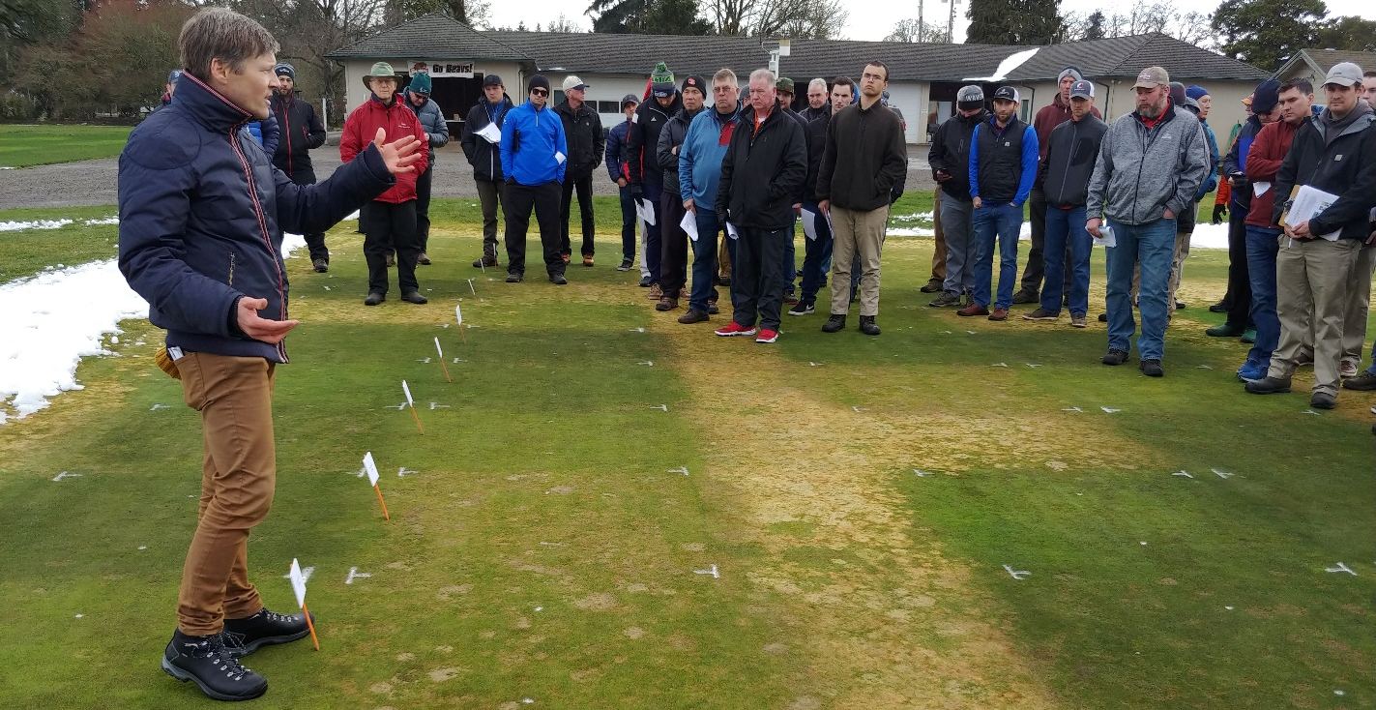

Schedule
8:00 am to 9:00 am – Check-in and Breakfast
9:00 am to 11:30 am - Field Day, Industry Expo
11:30 am to 12:30 pm – Lunch
1:00 pm to 7:00 pm – J. Oliver Memorial Golf Tournament and Dinner

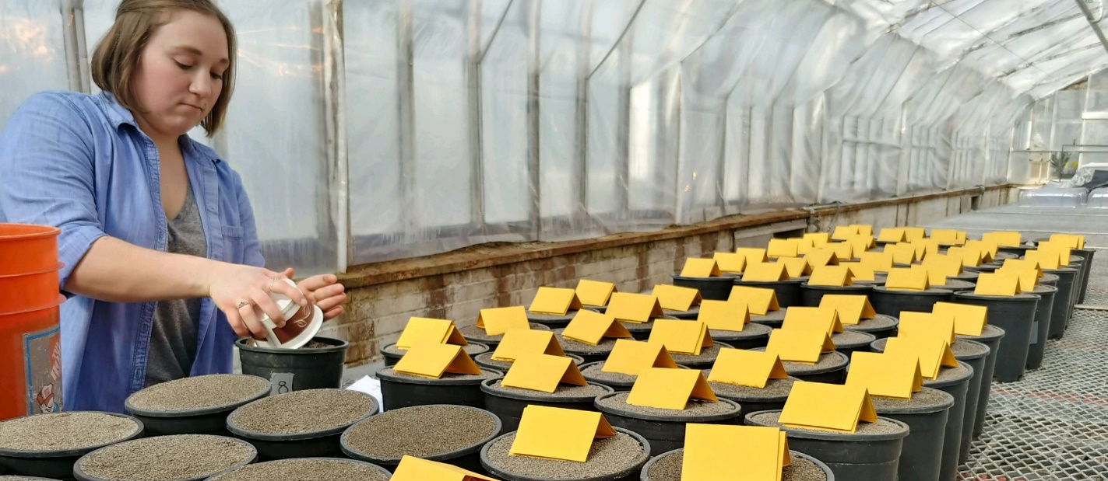
Field Day Topics
- Fungicide Alternatives for Microdochium
- Fungicides for Management of Anthracnose
- Annual Bluegrass Herbicide Resistance
- Fine Fescue Establishment
- Broadleaf Herbicide Trial Update
- Mowing Height and Frequency for Lawns
- Irrigation Rates and Frequency for Lawns
- Fertilizer selection, rates and timing
- Tall Fescue, Perennial Ryegrass, and Fine Fescue NTEP
- Spring Aerification and Fertilizer Timing for Lawns Drought Resistance

Full Package: Registration $90.00 (Due Aug 19). Onsite registration $115.
Registration includes breakfast, field day, lunch, golf and dinner.

Field Day Only: Registration $60.00 (Due Aug 19). Include field day and lunch, excludes golf and dinner.

Social Package: $35.00
Lunch at Lewis-Brown Farm, or Dinner at Trysting Tree Golf Course (Due Aug 19).

Industry Booth or Equipment Exhibitor: $90 (Due Aug 19).
Booth hours 9:00 am to 11:30 am at Lewis-Brown Turf Farm. Includes folding table (6’ x 2.5‘) and registration for 1 person (breakfast, field day, lunch, golf and dinner).

Golf Outing Tee Sponsor: $250

---------------------------- Registration ---------------------------------
Select a Package | Number | Total
Full Package ($90) |  | $
Field Day and Lunch ($60) |  | $
Social Package ($35 per meal)  Please specify lunch or dinner |  | $
Industry Booth or  Equipment Exhibitor ($90) |  | $
Golf Outing Sponsor ($250) |  | $
Name(s)
Employer
Address, City, State, Zip
Phone
Email
Checks payable to “OSU Foundation” or if paying by credit card, please complete the following information…
Name on Card
Address, City, State, Zip
Credit Card Type
Credit Card Number
Expiration Date
Return Payments via mail or fax to…
Alec Kowalewski, Ph.D
Turfgrass Specialist, Oregon State University
4147 ALS Building, Corvallis, OR 97331
Fax: (541)737-3479
For More information call: (541) 737-5449

