N.B. & Jacqueline Giustina Endowment:
July 1, 2021 - June 30, 2022 Report.

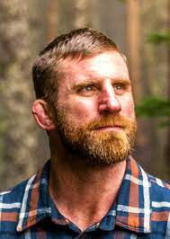
Alec Kowalewski, Ph.D.
Associate Professor, OSU Turfgrass Specialist
alec.kowalewski@oregonstate.edu

The N.B. & Jacqueline Giustina Professorship Endowment supports the sole turf faculty position within the Department of Horticulture at Oregon State University. The turf position is a two-way, 9-month appointment, and reflects the land-grant mission of Oregon State University. The Giustina Endowment funds the summer portion of my salary, which is the time of year when the majority of efforts will be directed toward research.
Accomplishments since hire (Dec 2012)
- Funding Generated: $6,101,027
- Stakeholders Reached: 22,748
- Presentations:391
- Publications: 347
- Press Releases: 68
- Site Visits: 117
- Scientific Presentations: 75
- International Presentations: 52
- Graduate Students: 8

The Giustina funds have allow the OSU Turf Program to focus on research and grow exponentially. The OSU Turf Program includes Research Assistants Brian McDonald and Emily Braithwaite, Research Associates Dr. Clint Mattox, Dr. Ruying “Wrennie” Wang and Dr. Chas Schmid, and Master of Science Graduate Assistants Cole Stover and Zach Hamilton.

Brian McDonald, Senior Research Assistant
As a Research Assistant at Oregon State University, Brian has been with the program for 20 years and has his office on-site year-round overseeing the day-to-day operations, conducting research trials, and supervising the undergraduate student workers.

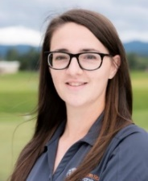
Emily Braithwaite, Research Assistant
Emily joined the OSU Turfgrass Management Program in 2017. Her work has been critical to ensuring the success of 2 multistate grants funded by the United States Department of Agriculture. These grants are titled 1) Low-Input Turf - Fine fescue, and 2) Annual Bluegrass Herbicide Resistance.

Dr. Clint Mattox, Research Associate
Clint completed his Ph.D. in Horticulture at Oregon State University in 2020. Clint’s M.S. and Ph.D. research focused on alternative methods of controlling turfgrass diseases, notably Microdochium patch on Poa annua putting greens.

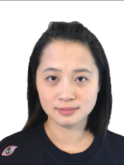
Dr. Ruying “Wrennie” Wang, Research Associate
Dr. Wang completed an undergraduate degree at Michigan State University, and M.S. and Ph.D. at Rutgers University. Dr. Wang’s current research is focused on Epichloe endophyte transference across turfgrass genus and species to improve stress and disease tolerance.

Dr. Chas Schmid, Research Associate
Chas has a B.S. in from The University of Nebraska, and a M.S., and Ph.D. from Rutgers University. Dr. Schmid’s current research is evaluating the long-term effects of cultivation and topdressing on putting greens and improving aerification recovery with plant growth regulators.

Cole Stover, Master of Science Graduate Assistant
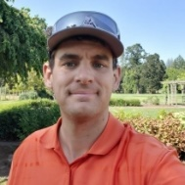
The objective of Cole’s M.S. dissertation is to identify the various micro-environmental conditions that cause localized winterkill, and evaluate cultural practices to mitigate the effects of the winter turfgrass pathogen Microdochium patch. For this research Cole is collecting environmental data for golf courses in Bend, OR and conducting field experiments in Corvallis, OR.

Zach Hamilton, Master of Science Graduate Assistant
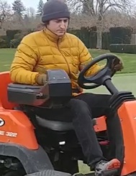
The objective of Zach’s M.S. dissertation is to assess the adult flight duration, early instar period, and distribution of European chafer in Western Washington and Oregon. For this project Zach is visiting golf courses between Everett, WA and Portland, OR to collect insect samples using light traps and soil sampling.

Upcoming Community Outreach Events
- 2022 Summer Field Day, Sept 1, 2022, Lewis Brown Farm, Corvallis, OR, 8:00 am to noon
- 2022 Jason Oliver Memorial Golf Outing, Sept 1, 2022, Trysting Tree Golf Club, Corvallis, OR, 1:00 pm to 5:00 pm
- Registration for these events is free, to RSVP email alec.kowalewski@oregonstate.edu

