Tomato Grafting at Even Pull Farm: Pictures
Beth Satterwhite

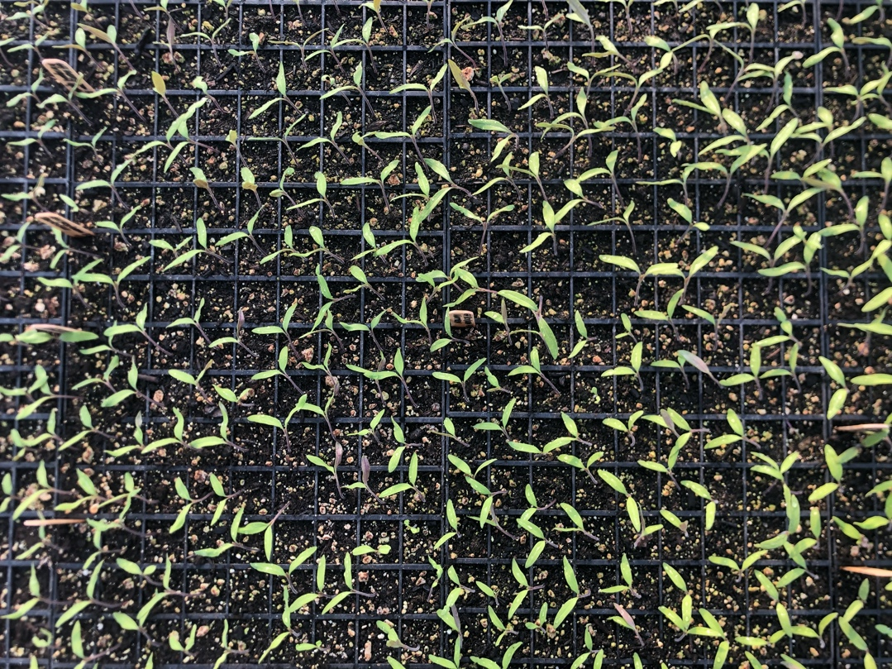

Here are our 2022 scions which are growing on our heat mats currently (picture taken 1/27). You can see that I seeded into every cell in the tray. These will get moved indoors under lights as soon as I can get the plant rack set up again at home (photo of that on the next page).

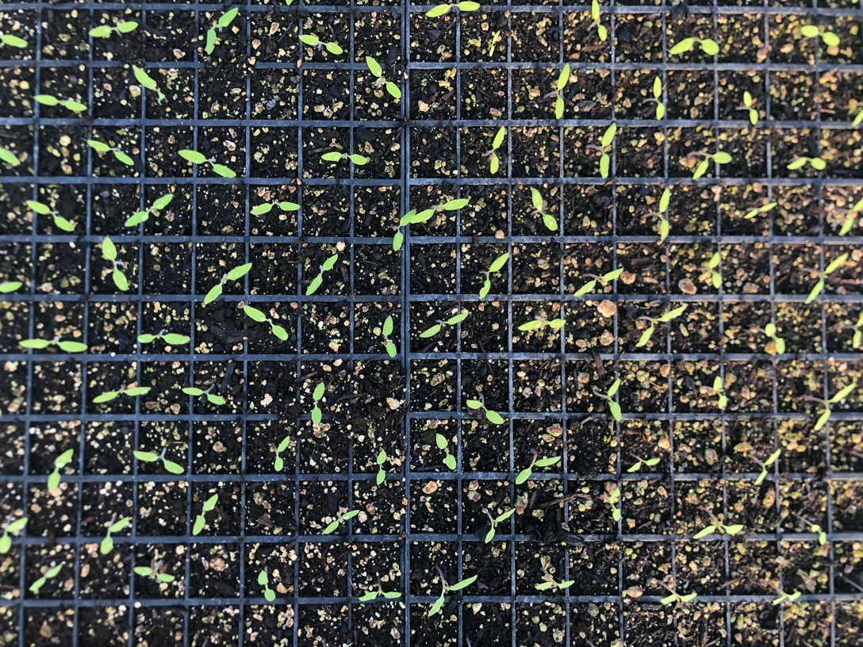
These are our 2022 rootstock plants growing on heat mats (picture taken 1/27). Seeded every other cell to allow more room for your hands when you get to the grafting stage.
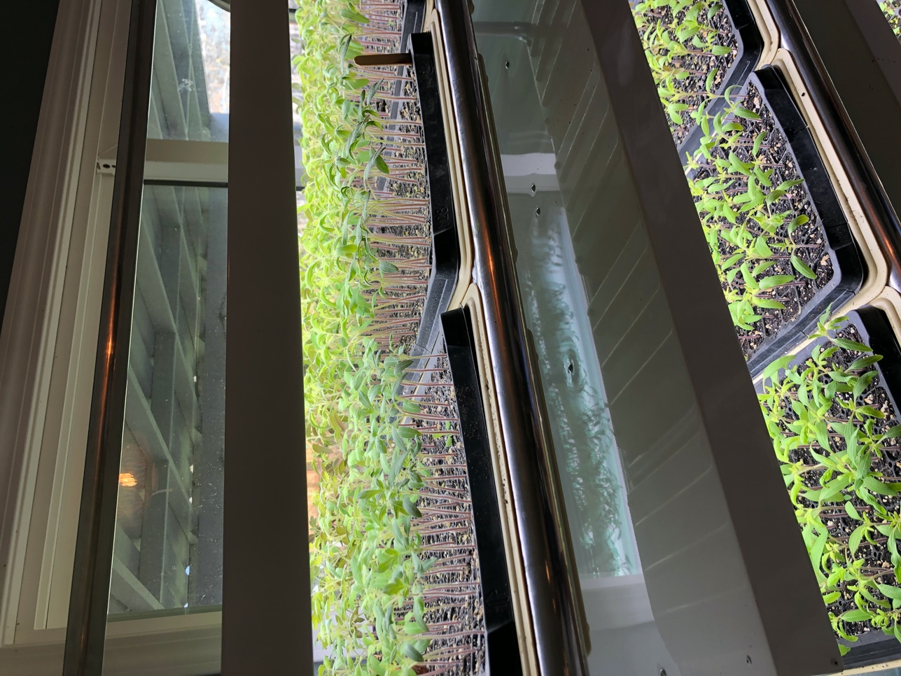
Here is a photo of our 2021 tomatoes for grafting growing on a light rack in our house. We minimally heat our prop house, and between that and the lack of light early in the year we have chosen to grow the plants on indoors until sized up for grating. Last year I had a real discrepancy in size between scion and rootstock stems, so I did let things size up more than is maybe ideal and fiddled with the number of hours of light things were getting to try to even them out. It kind of worked. Also, the grafts worked just fine with uneven sizes!
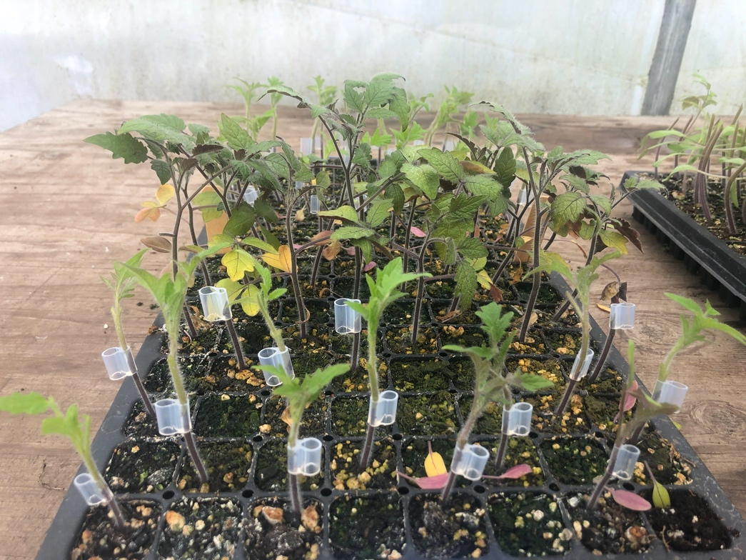
A not-so-gorgeous photo of my 2021 tomatoes mid graft. For some reason I am working the wrong direction here, I usually start at the middle of the tray and work toward myself. I had to work pretty hard to get stem sizes to match last year, so that might be part of why I did it in the wrong order or jumped around a bit. You can see the plants aren’t super-duper happy here. Getting hungry/possibly overwatered a tad while they grew indoors. You can also see here (if you look at the grafted plants and compare them to the middle rows) the extent of the trimming I do to the foliage. These plants were on the larger side, so trimming off a good percentage of foliage (50% or so) was even more important to slow transpiration while they healed. I take off half of all larger leaves and remove cotyledons. Even though this doesn’t look that great, I had 90%+ success with my grafts last year. My grafting date last year was 2.25, about 5 weeks after seeding—I’d ideally do this on week 4.

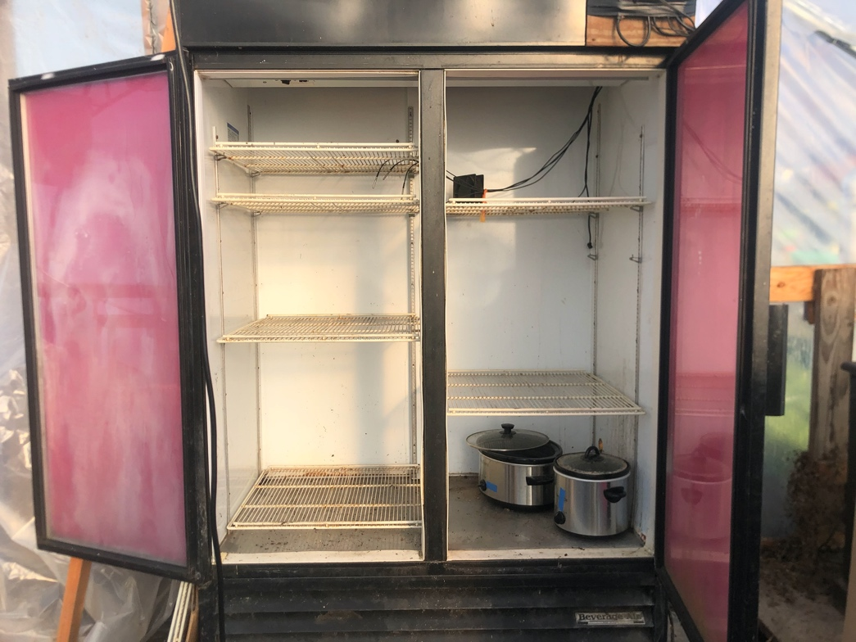
Here is a photo of our germination chamber which I use as our healing chamber for the tomatoes. The two crockpots in the bottom are our heat and humidity sources. They are connected to sensor/monitors that keep humidity and temperature in a 5%/5* range. I set temp to 85* and humidity to 90*. To get the last humidity bump for healing grafts I use a humidity dome on my trays inside the germ chamber. Before loading anything in here, I sweep it clean (wash it down if very dirty), and spray all surfaces with Sanidate sanitizer. There are lots of plans for germination chambers available online, we used one published my Michael Kilpatrick.

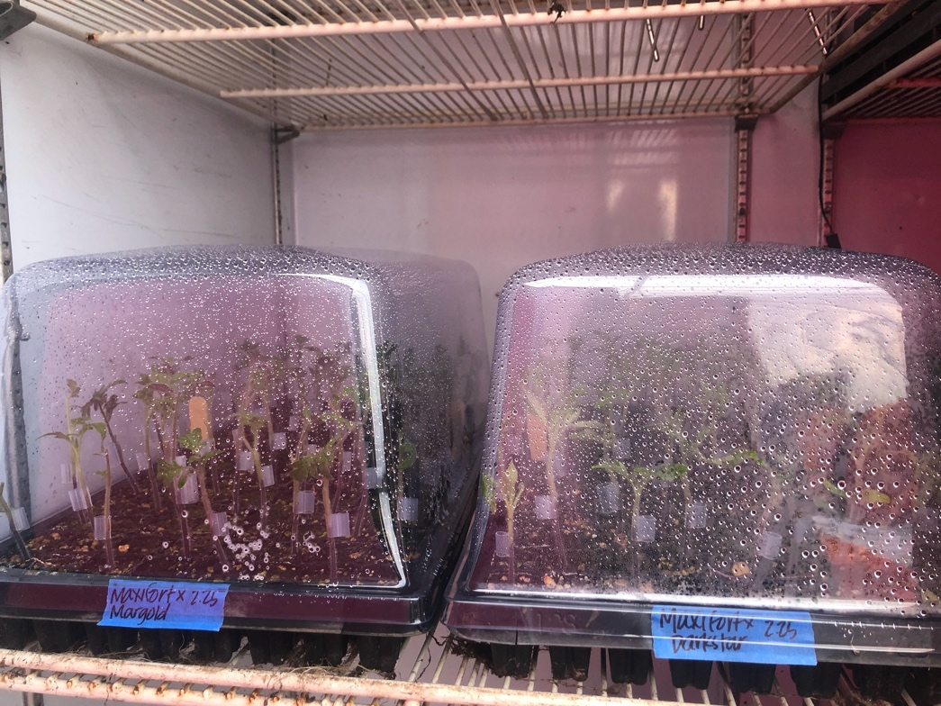
Here are the freshly grafted tomatoes just loaded into the germ chamber (this photo is from 2021). I label using pot sticks AND tape on the tray itself, noting the scion & rootstock varieties and the date of the graft. In case you forget how long you’ve left them in there, you have a reminder. On trays with multiple varieties I will do tape labels along the long edges of the tray too.
You can see there is a lot of moisture on the inside of the domes: I thoroughly mist the plants and the inside of the dome with water (using a spray bottle) before loading them in. All vents on these domes are closed to start to get as close to 100% humidity as possible.

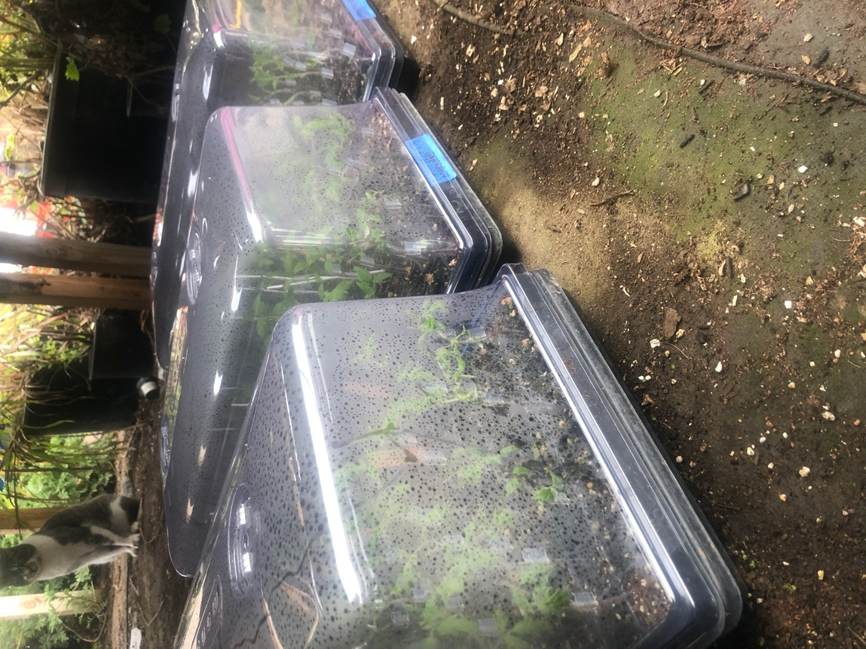
Here are our 2021 tomatoes on their first day outside of the healing chamber. You can see they are a little bent to the side, that’s because our germination chamber isn’t 100% dark and they start to lean over the course of the healing timeline (can be offset by stakes). I believe it was chilly when I removed our tomatoes last year so I reclosed all of the vents on the domes to keep them a bit more protected from drafts. They spend about 24 hours under the tables getting reacclimated to sunlight before I pop them back up on the tables and onto a heat mat to encourage them to start growing rapidly again.
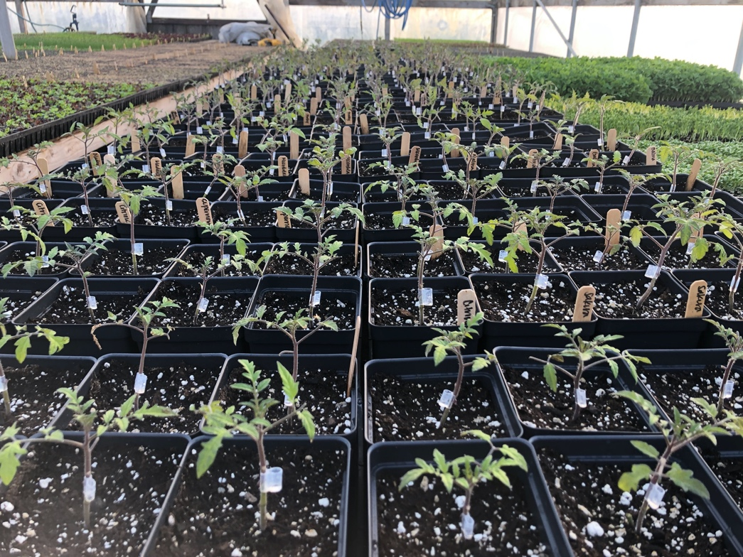
Here are our fully healed and potted up grafted tomatoes (2021)! They got potted up 4 weeks after grafting (late March), which is honestly too long to wait but I didn’t have any staff last winter so I just did it when I got to it! I pot on into 5” pots, leaving their clips in place. If I used any grafting stakes in the trays to support plants I will remove them now because the plants are really going to take off and bury the little stakes. They will naturally shed the grafting clips as they rapidly grow up to plantable size, and you can pluck the clips out before you top dress them with fertilizer ahead of planting. I will top dress about 10-14 days ahead of my transplant date so that they are fully happy and growing at the point of transplant.

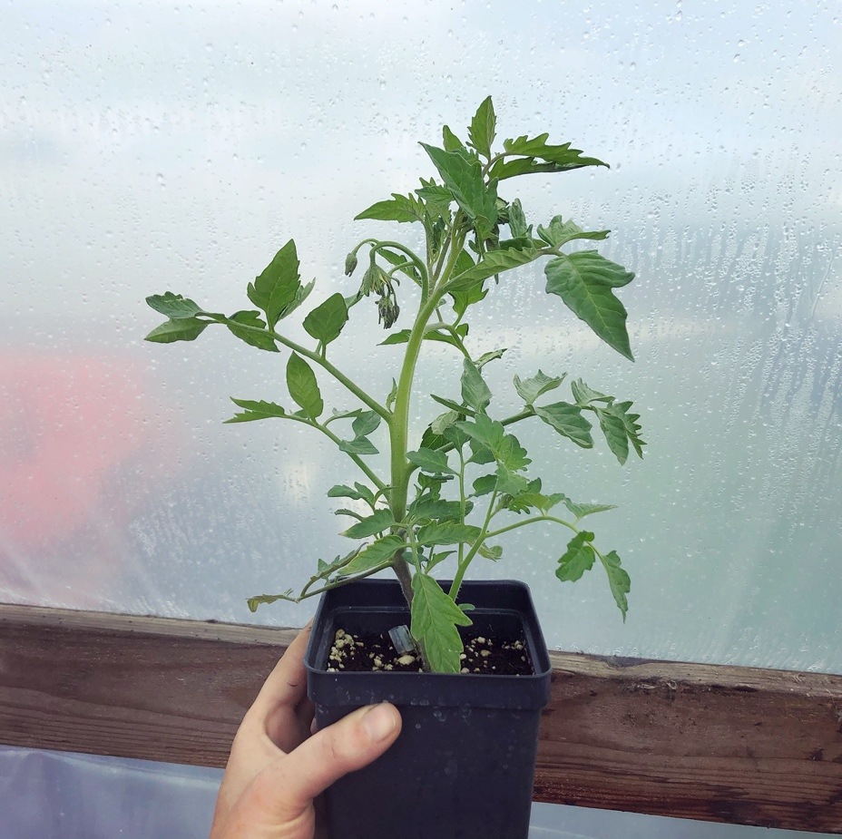
Here is a grafted tomato at the stage I like to transplant them. This photo is from early April 2021, and we eventually ended up planting the last week of April (if you remember we had lots of very frosty nights late into April last year, so I delayed planting by a few weeks past my target since we do not heat our tomato house). We picked our first fruit off of these plants in July. You can see the popped-off grafting clip laying in the soil there, and that these plants are just about ready to flower. I like to transplant at this size, stake, hoop, row cover & let them grow until they’re busting out of the covers. That gives them a little heat boost and protection while they get established so we hopefully don’t slow down growth TOO much. This all would definitely would work much better in a heated tunnel & we would get earlier fruit that way, but we haven’t taken the plunge on that yet. Once we uncover, we will give them their first prune (establish 2 leaders), and clip them to their twine. Then they’re off!
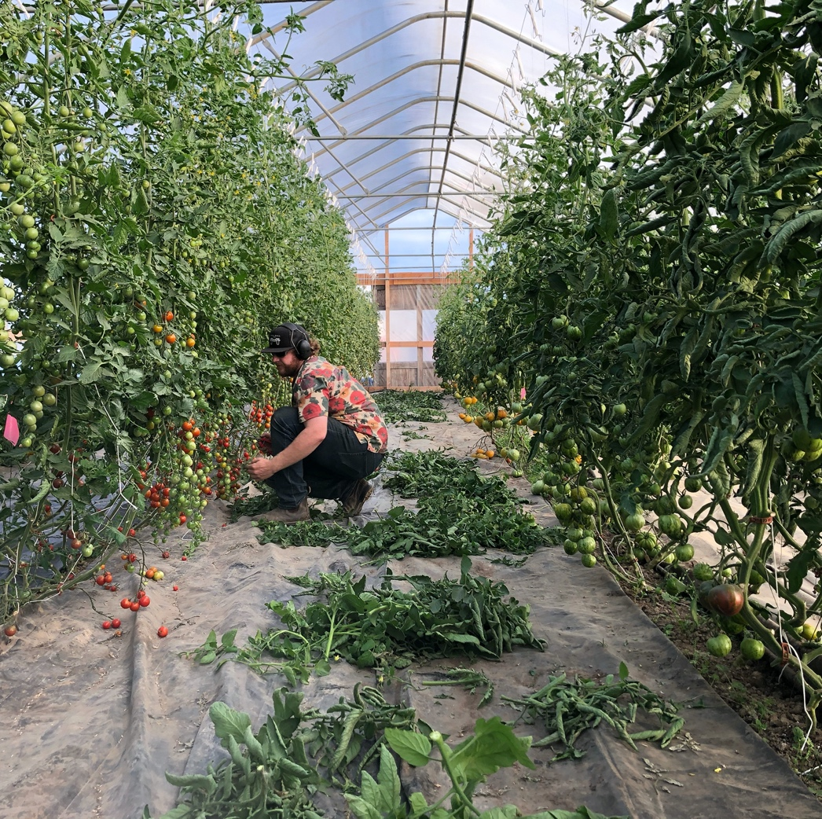
This is our tomato house in mid-July last year (2021). We have been picking cherries for a few weeks at this point (left), and are starting to get large harvests on our heirlooms (right). Maintaining grafted tomato plants is a lot of work. I’d guess about 4 hours a week of pruning and trellising work (1 hour a bed *if* you keep up on it; if not it will take much longer!). They are extremely vigorous and set a lot of fruit (which is the goal for us!). Here we are beginning to remove more lower foliage on the plants so allow better airflow and to get more light on the fruit to encourage ripening.

