Softball and Baseball Field Maintenance
Cole Stover, Zach Hamilton, and Alec Kowalewski
Department of Horticulture, Oregon State University

Infield Turfgrass Management – Primary Cultural Practices

Turfgrass management in the infield area should focus on consistent mowing, fertilization and irrigation.

Mow the infield at 1” during the playing season 3 times per week. To accomplish the increased mowing frequency during the season a volunteer could mow with a walk behind push mower. During the offseason raise the mowing height to 2.0” and reduce the mowing frequency to once per week. Slowly lower the mowing height in increments to prevent scaling when transitioning from 2” to 1”. Change mowing direction to reduce the formation of ruts and soil compaction. Use a mulching mower blade to return grass clippings. Returning turfgrass clippings will recycle nutrients into the soil making the turfgrass healthier. If clippings become excessive use a bagger with the mower to remove the clippings.

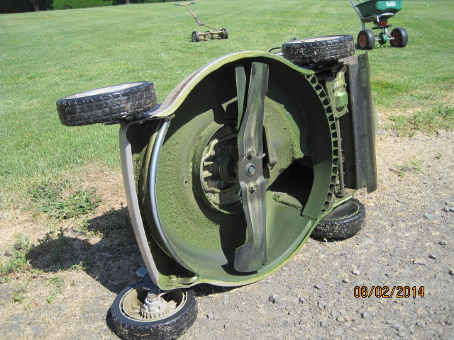Mulching mower blades will help facilitated return grass clippings.

Regular fertilizer applications should be made to the turfgrass in high traffic areas. For the best results these applications should be made in the spring and the fall months. These applications should include 1 lb N per 1,000 sq ft per application, totaling 6 applications (6 lbs N per 1,000 sq ft) per year. Select a fertilizer with high levels of nitrogen, low levels of phosphorus and moderate levels of potassium. A sample ratio of 25-3-5 would work well. Fertilizer should be applied with rotary style spreader. A fertilizer with an edge guard is preferred to prevent fertilizer from going to the skinned area, which otherwise would be a waste of product and stimulate weed growth in these areas.

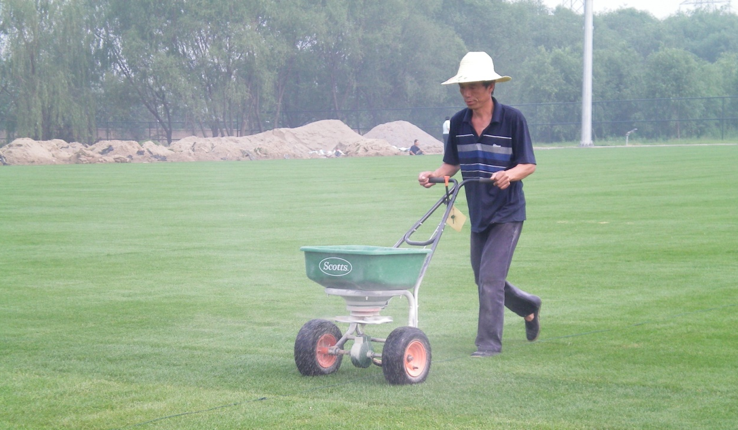
Applying fertilizer with a rotary fertilizer spreader.

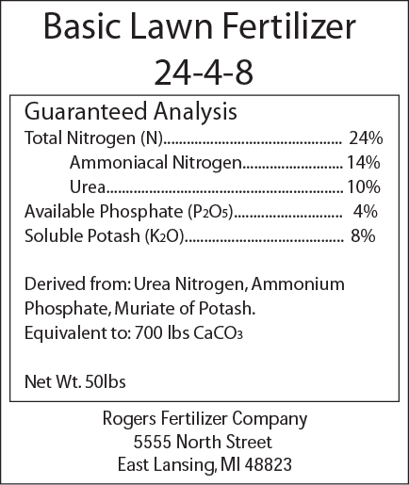
Apply a fertilizer with a high concentration of nitrogen (N), low concentration of phosphorus (P₂O₅) and moderate level of potassium (K₂O).

The infield will require extra water during the warmer months. Daily irrigation at 0.2” may be required during periods of excessive drought and heat. Supplementing existing irrigation on the grass infields using a hose and impact sprinkler. A hand nozzle is also a useful tool for hand watering the infield. A rain gauge can be used to determine how long the irrigation should be run to accomplish 0.2”.
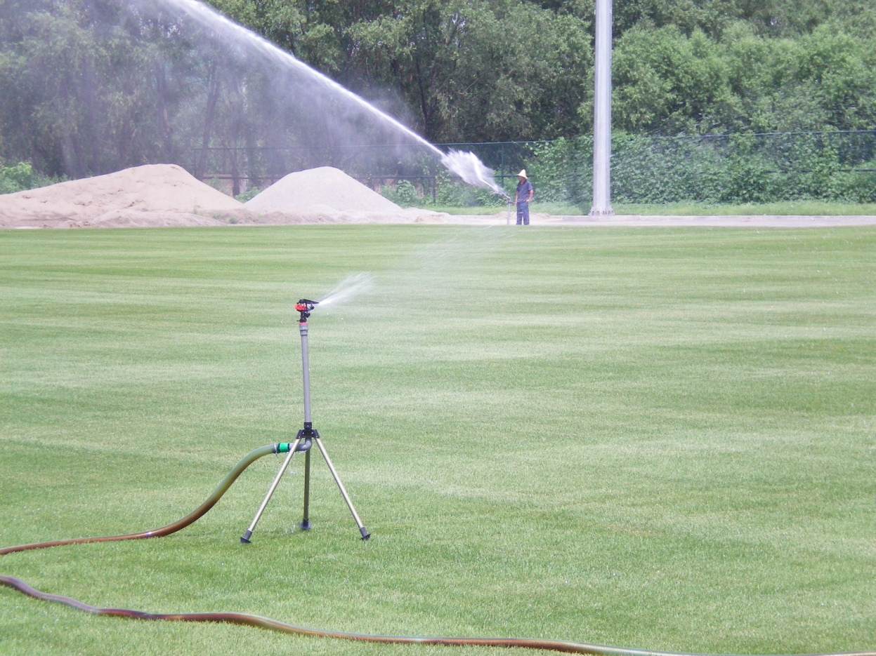
A hose and impact sprinkler can be used to supply supplemental irrigation to the infield.

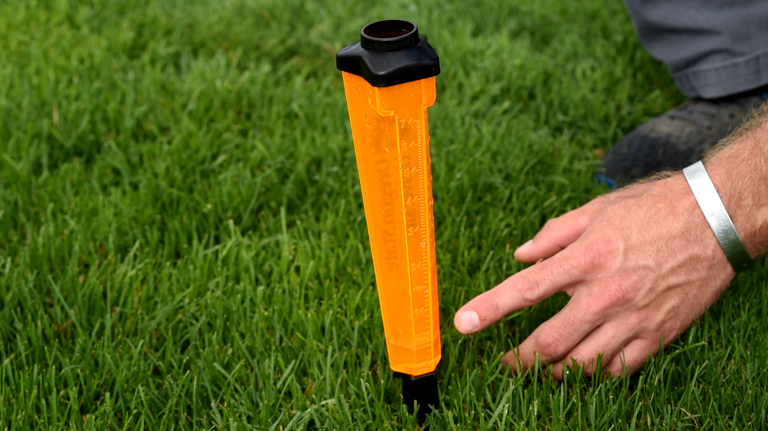
Use a rain gauge to determine how long it takes to apply 0.2” of water.

Infield Turfgrass Management – Secondary Cultural Practices

Secondary cultural practices include spring rolling, aerification, inter-seeding, broadleaf weed management and rodent control. Again, successful turfgrass management will require consistent primary cultural practices: mowing, fertilization and irrigation. These primary cultural practices should not be skipped in place of the secondary cultural practices described below. Rather the secondary cultural practices should be skipped when resources are limited.

In the spring prior to the initiation of the season rolling will help smooth the playing surface. Small hand pulled and large tractor pulled rollers that are filled with water can be used to complete this process.

If the turfgrass density within the infield becomes sparse and the soil is compacted aerification and inter-seeding will be needed. To relive soil compaction, it is best to perform aerification with a hollow tine core cultivation unit. Cores should be removed from the soil surface after this process. These holes can be filled with sand topdressing, compost, topsoil or left open. Aerification and sand topdressing will likely need to be contracted due the specialized equipment associated with these practices. Inter-seeding can be used to fill in bare areas or increase turf density when it is thin. Inter-seeding can be coupled with aerification or be completed without aerification. For best results inter-seed with perennial ryegrass at 10 lbs seed for 1,000 sq ft for fast germination in the spring or fall months.
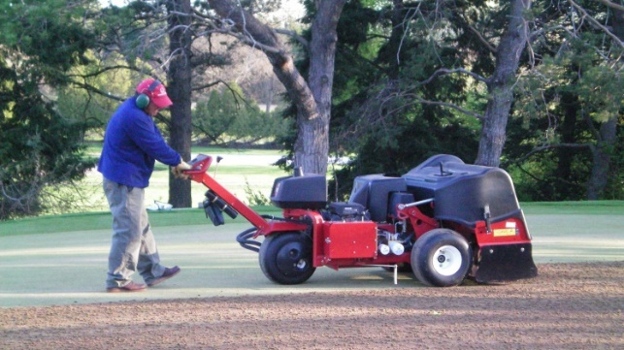
Hollow tine core cultivation will reduce soil compaction and improves establishment when done prior to inter-seeding.

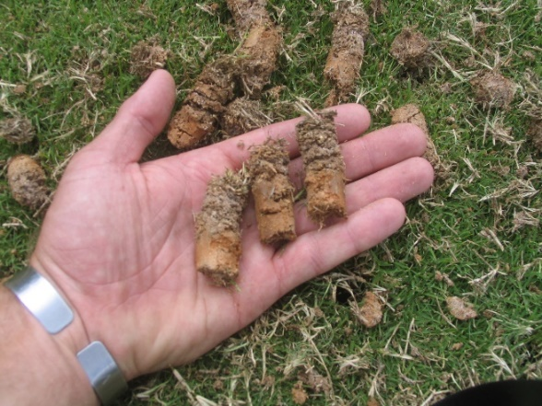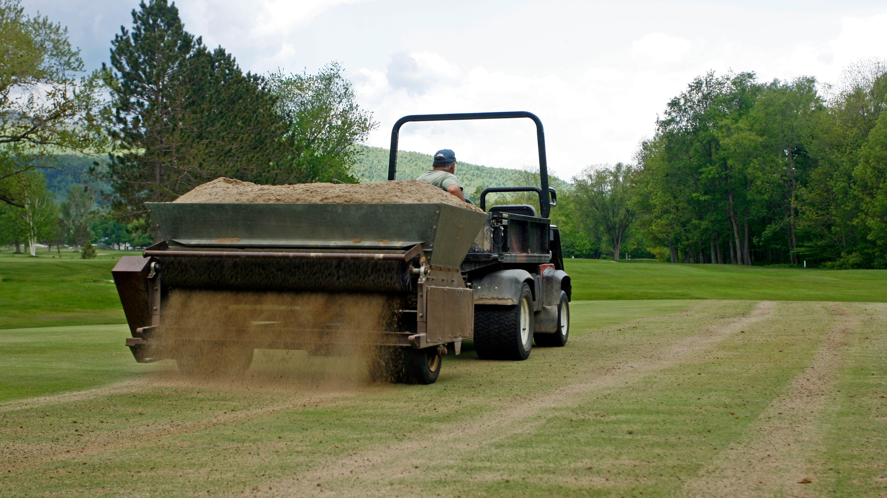
Soil cores (left) should be removed after aerification and replace with sand, compost of native soil topdressing (right).

Common dandelions, false dandelion and clover are common broadleaf weeds observed in turfgrass athletic fields. These weeds can be selectively removed using selective broad leaf herbicides with 2,4-D, triclopyr, MCPP and dicamba. For best results make these herbicide applications in the fall, when temperatures are cool. The active ingredient 2,4-D will remove dandelion very well, while triclopyr will work well on clover. Frequent mowing, fertilization and irrigation will prevent these from returning.

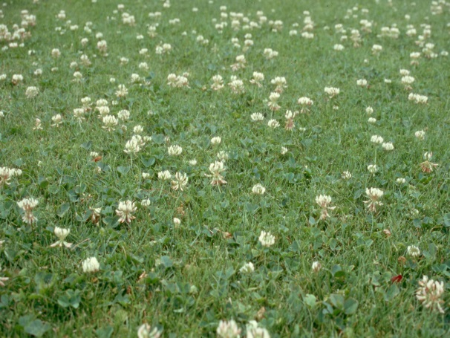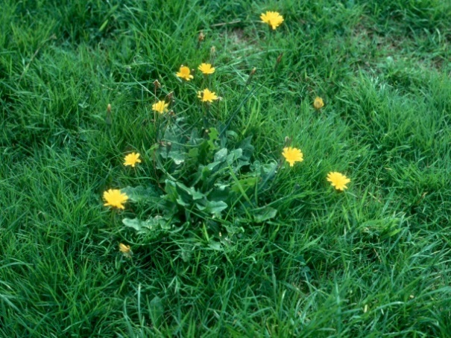
White clover (left) and false dandelion (right) are common weeds in under fertilized turfgrass areas.

Scout for and trap gophers in the early spring prior to reproduction, and moles in the spring and fall. The scissor trap is most effective on moles while the synch trap is the best for gophers. Trapping gophers and moles requires skill and technique. Considering these the following videos are excellent reference on trapping techniques for these pests…

“How To Catch Gophers With the Cinch Trap”
https://www.youtube.com/watch?v=DLOon6tptDY

“Pro Tips For Catching More Moles”
https://www.youtube.com/watch?v=w08d1FQW30I
Infield Sinned Area Management

The dirt areas of the infield should be raked before and after every practice during the season to prevent weed establishment and improve the infield playing conditions. It would be best to incorporate the players and volunteers into these aspects of the field maintenance. In addition to frequent hand raking more aggressive cultivation can be done periodically with a nail drag rake.
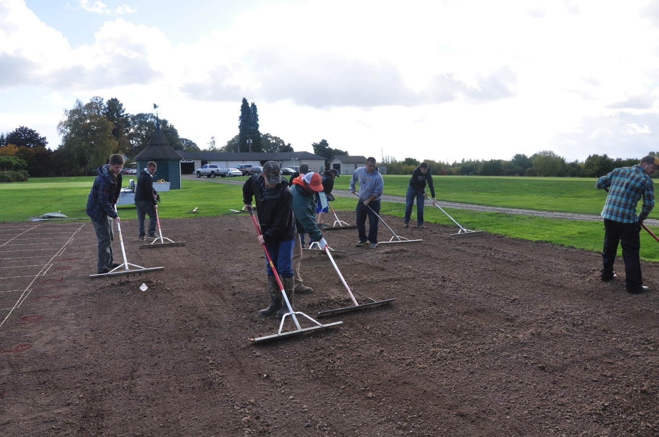 Hand raking before and after practice will help prevent weed establishment and provide a smooth infield.

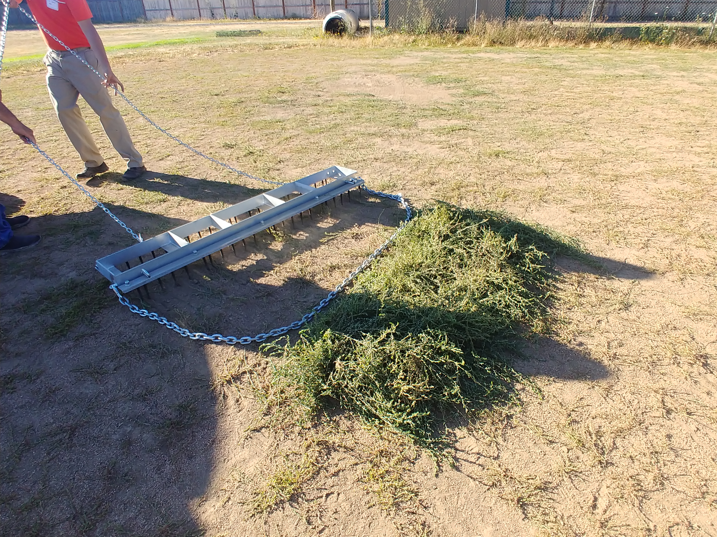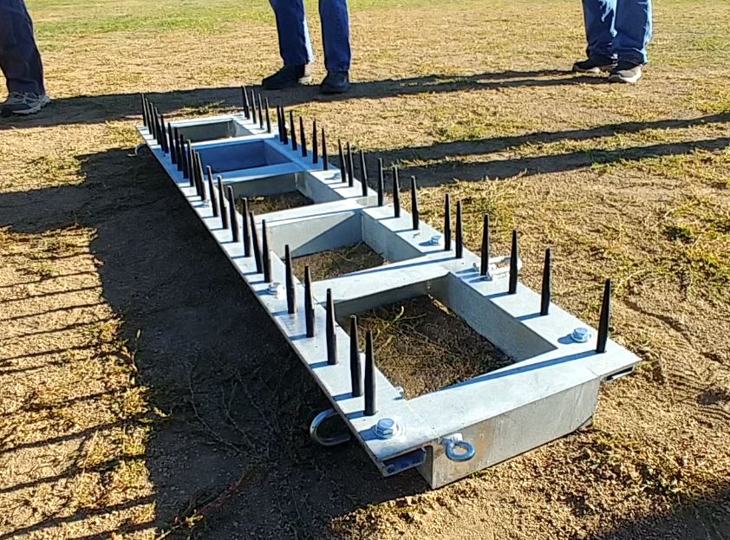

A nail drag is more aggressive than hand rakes that can be used to remove vegetation (left), bottom view of the nail drag (right).

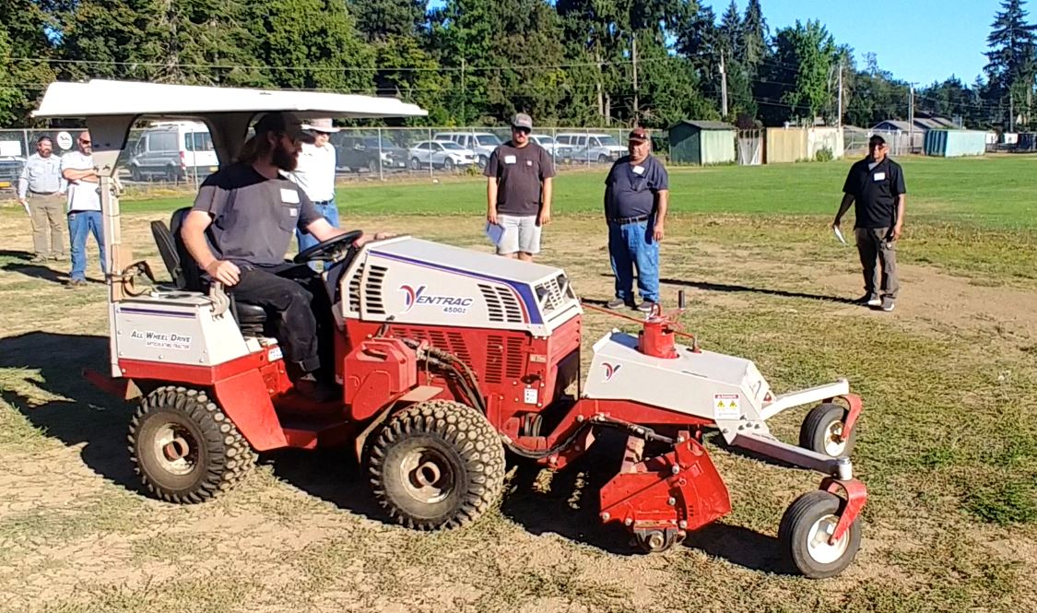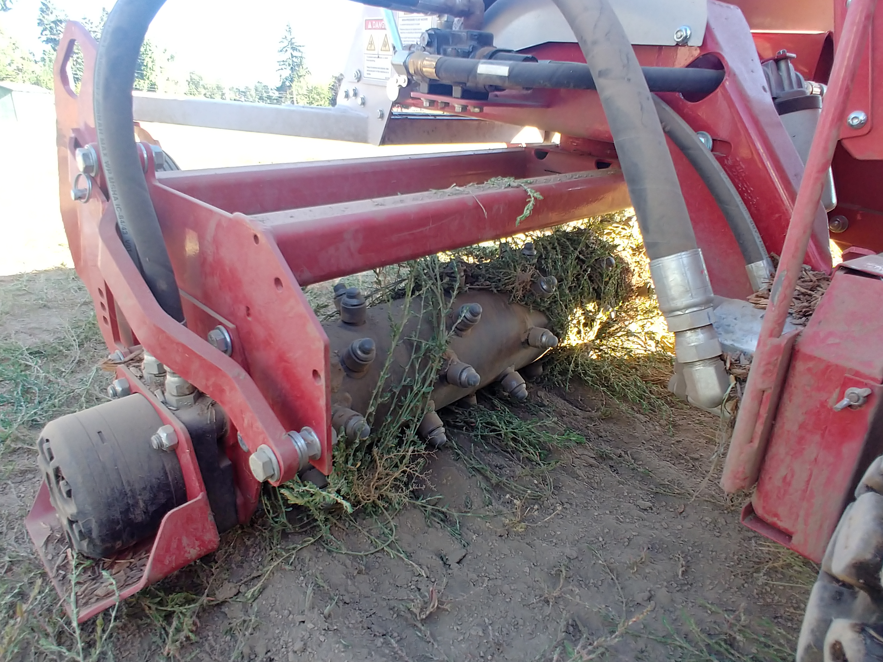
The Ventrac is an aggressive infield grooming tool, which can be used to remove vegetation (left and right).

After the playing season the dirt areas of the infield should be tarped to prevent weed germination, and the development of algae. If a tarp is not feasible a pre-emergent herbicide like pendimethalin (Pendulum) or prodiamine (Barricade) applied in the early spring or early fall could also be used to prevent weeds from germinating. We had identified summer annuals (knotweed) and winter annuals (annual bluegrass and pineapple weed), which would be controlled nicely with a spring and fall pre-emergent herbicide applications, respectively. The use of pre-emergence herbicides in place of a tarp will results in more weed cleanup prior to the start of the season.

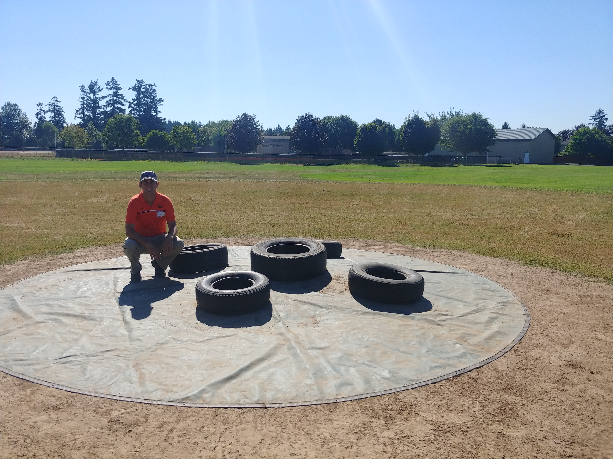
Infield tarps will prevent weed establishment and reduce spring clean-up.

Outfield Turfgrass Management

The outfield area should be mown once a week year-round (weather permitting), at 2 to 3”. Change up direction to prevent ruts and soil compaction. If possible return grass clippings to recycle nutrients into the soil.

Outfields should be fertilized two to four times per year at 1 lbs N per 1,000 sq ft. For the best results these applications should be made in the spring and the fall months. These applications should include 1 lb N per 1,000 sq ft per application, totaling 2 to 4 lbs N per 1,000 sq ft per year depending on the number of applications made. Select a slow-release nitrogen source fertilizer, polymer coated urea, or methylene urea for instance. The fertilizer should have high levels of nitrogen, low levels of phosphorus and moderate levels of potassium. A sample ratio of 25-3-5 would work well. Fertilizer should be applied with rotary style spreader. A fertilizer with an edge guard is preferred to prevent fertilizer from going to the skinned area, which otherwise would be a waste of product and stimulate weed growth in these areas.

When available utilize irrigation to maintain healthy turf. A general rule of thumb in the summer would be 4 irrigation events per week at 0.25 to 0.3” of water. However, during periods of extreme drought and heat stress more frequent irrigation will be required to prevent the development of stress symptoms and summer dormancy.

The secondary cultural practices: rolling, aerification, inter-seeding, broadleaf weed control, and rodent control measures described in the infield turfgrass management section can also be used in the outfield. However, the emphasis should be consistent mowing, fertilization and irrigation to sustain healthy turfgrass.

Field User Recommendations

The practice drills typically utilized by teams to improve their skills can be very hard on the fields if the location of the drill is not rotated. We would recommend using alternative areas on the field to spread the wear and tear more evenly and improve the overall quality of the field. Encouraging the players to participate in the field maintenance will instill a sense of pride in their field, and could foster some more home field advantage if the players feel more invested.

