**Tolerance of Seed Radish to Clopyralid: Effect of Variety, Timing and Rate, 2010-11**

E. Peachey, J. Green, and A. Greco  
Oregon State University, Corvallis, OR

Clopyralid provides exceptional control of weeds of the Asteraceae family, including Canada thistle. Clopyralid is not labeled for use in radish grown for seed or for roots. Clopyralid residue studies are currently in progress, but crop safety must be demonstrated before a label will be approved. Synthetic auxin herbicides such as clopyralid occasionally impact seed germination. The objective of this study was to determine the effect of clopyralid on both radish plant and seed yield, and seed germination. Greenhouse and field experiments in 2010 measured the effect of clopyralid on radish grown for seed.

**Greenhouse study (2010)**

Thirteen radish varieties that included male (M), female (F) and open pollinated lines were planted in OSU glasshouses on March 05, 2010 (Table 1). Clopyralid was applied at 0.125 lb ai/ha and 0.250 lb/A at 2-6 leaf stage and prior to bolting. Plants were harvested on May 26, dried and weighed. Clopyralid caused slight visual symptoms on 3 varieties, but visual injury did not correlate well with effects on shoot and root yield. Clopyralid rate was the primary factor influencing shoot yield; application timing was the main factor influencing root yield. Visual injury was a poor predictor of plant height, shoot dry weight, and root fresh wt (corr. coefficients <0.1). Average plant height of VAR 67673M, 167677F, and RF-44M was reduced by as much as 18%, 27%, and 21%, respectively (Figure 1). Shoot dry weight was reduced by as much as 37%, 18% and 19% for the same varieties, respectively. Shoot dry weight of varieties 623414F, RF-132M, and radish (B,GS) increased by 35%, 21%, and 42%, respectively when clopyralid was applied at 0.250 lb ai/A.

**Field Studies (2010 and 2011)**

Plots were located near Amity OR in 2010 and Salem in 2011. Clopyralid was applied to both male and female rows of plants at 0.125 lb ai/A and 0.25 lb ai/A to radish at the 4 to 6 leaf stage or just as radish began to flower.

In 2010, clopyralid caused very little visual injury to radish except when applied at 0.25 lb ai/A to the radish male plants that had just begun to flower (Table 2). Plant biomass of the radish variety RF-17(F) was reduced when clopyralid was applied near bolting at 0.25 lb ai/A (see table below). The male line of this variety was visibly damaged while the female line was not. Seed yield of the same treatment was reduced by nearly 25% when clopyralid was applied near bolting at 0.25 lb ai/A (tr. 4). No other treatments were impacted. Time series ANOVA of data from seed germinated on a temperature gradient table indicated that clopyralid may have enhanced seed germination slightly, and that the effect was greatest shortly after harvest (Figure 2). There was no effect of clopyralid on radish growth when seeds from the 2010 experiment were planted in the spring of 2011.

In 2011, clopyralid damage to radish was not visible in field plots at either rate or timing (Table 3) although there was some indication at the latest evaluation that growth was slightly reduced. However, drymatter weights are harvest did not reflect this result. Seed yield was apparently impacted as in the year before at the 2x rate clopyralid, particularly at the 0.250 lb ai/A when applied after flowering had begun. Seed germination tests indicated slight effects if any on seed germination.

**Table 1.** Effect of clopyralid applied at 0.125 (1x) and 0.25 (2x) lbs ai/A EPOST or LPOST to radish. Values followed by an asterisk (*) in the same column and within variety differ from the untreated check (α =0.05).

| Variety, Rate, Timing (lf stage) | | | | | | Shoot dry wt. (g) | Root fresh wt  (g) | Plant ht (cm)  ht of tallest vegetative leaf at harvest | Phytotoxicity rating at harvest  (0=none; 10 =complete death) |
| --- | --- | --- | --- | --- | --- | --- | --- | --- | --- |
| **167677 (Female)** | | | | | |  |  |  |  |
| Untreated check | | | | | | 3.6 | 100.8 | 15.8 | 0 |
| 1x, EPOST (2.5 lf) | | | | | | 2.7 | 76.3 | 13.6 | 0 |
| 1x, LPOST (10 lf) | | | | | | 3.6 | 107.9 | 13.4 | 0 |
| 2x, EPOST | | | | | | 2.6 | 104.8 | 14.8 | 1* |
| 2x, LPOST | | | | | | 3.5 | 102.4 | 14.4 | 0 |
| Anova  (p-value) | | Rate | | | | ns | ns | ns | <0.001 |
| Timing | | | | 0.02 | ns | ns | <0.001 |
| **67673 (Male)** | | | | | |  |  |  |  |
| Untreated check | | | | | | 2.9 | 79.3 | 19 | 0 |
| 1x, EPOST (2.3 lf) | | | | | | 3.1 | 82.6 | 16.4 | 0.4 |
| 1x, LPOST (10 lf) | | | | | | 2.6 | 82.4 | 15.8 | 0 |
| 2x, EPOST | | | | | | 2.4 | 77.3 | 16.8 | 0.6* |
| 2x, LPOST | | | | | | 2.7 | 76.5 | 15 | 0 |
| Anova  (p-value) | | Rate | | | | ns | ns | 0.05 | ns |
| Timing | | | | ns | ns | ns | 0.01 |
| **RF 44 (Female)** | | | | | |  |  |  |  |
| Untreated check | | | | | | 4.2 | 145.1 | 16.8 | 0 |
| 1x, EPOST (2.3 lf) | | | | | | 4.2 | 174.4 | 18.0 | 0.2 |
| 1x, LPOST (14 lf) | | | | | | 4.3 | 139.2 | 17.2 | 0.2 |
| 2x, EPOST | | | | | | 3.4 | 144.2 | 16.2 | 0.8* |
| 2x, LPOST | | | | | | 4.7 | 146.0 | 16.2 | 0.2 |
| Anova  (p-value) | | | | | Rate | 0.04 | ns | 0.05 | 0.05 |
| Timing | ns | ns | ns | ns |
| **RF 44 (Male)** | | | | | |  |  |  |  |
| Untreated check | | | | | | 11.1 | 94.5 | 21.0 | 0 |
| 1x, EPOST (2.9 lf) | | | | | | 11.3 | 92.6 | 19.6 | 0 |
| 1x, LPOST (18 lf) | | | | | | 9.3 | 89.6 | 19.2 | 0 |
| 2x, EPOST | | | | | | 13.6 | 59.5 | 16.4* | 0.3* |
| 2x, LPOST | | | | | | 13.8 | 63.9 | 17.4 | 0 |
| Anova  (p-value) | | | Rate | | | 0.04 | 0.07 | 0.04 | ns |
| Timing | | | ns | ns | ns | ns |
| **RF 132 (Female)** | | | | | |  |  |  |  |
| Untreated check | | | | | | 8.1 | 115.0 | 17.3 | 0 |
| 1x, EPOST (2.2 lf) | | | | | | 7.1 | 130.2 | 16.6 | 0.4 |
| 1x, LPOST (15 lf) | | | | | | 8.7 | 120.6 | 17.2 | 0 |
| 2x, EPOST | | | | | | 8.3 | 128.5 | 17.6 | 0 |
| 2x, LPOST | | | | | | 8 | 108.1 | 17.6 | 0 |
| Anova  (p-value) | Rate | | | | | ns | ns | ns | ns |
| Timing | | | | | ns | ns | ns | ns |
| **RF 132 (Male)** | | | | | |  |  |  |  |
| Untreated check | | | | | | 3.7 | 94.6 | 16.5 | 0 |
| 1x, EPOST (2.4 lf) | | | | | | 4.6 | 104.9 | 18.0 | 1* |
| 1x, LPOST (17 lf) | | | | | | 4.6 | 140.5 | 15.8 | 0.1 |
| 2x, EPOST | | | | | | 4.6 | 99.0 | 17.6 | 2* |
| 2x, LPOST | | | | | | 4.1 | 138.3 | 15.2 | 0.3 |
| Anova  (p-value) | | Rate | | | | ns | ns | ns | <0.001 |
| Timing | | | | ns | ns | 0.002 | <0.001 |
| **RF 131 (Female)** | | | | | |  |  |  |  |
| Untreated check | | | | | | 5.5 | 124.8 | 14.8 | 0 |
| 1x, EPOST (2.1 lf) | | | | | | 4.7 | 82.0* | 15.4 | 0.4 |
| 1x, LPOST (16 lf) | | | | | | 6.2 | 131.5 | 14.8 | 0 |
| 2x, EPOST | | | | | | 5.6 | 147.4 | 15.8 | 0 |
| 2x, LPOST | | | | | | 6.3 | 139.7 | 16.2 | 0 |
| Anova  (p-value) | | Rate | | | | ns | 0.06 | ns | ns |
| Timing | | | | ns | ns | ns | ns |
| **RF 131 (Male)** | | | | | |  |  |  |  |
| Untreated check | | | | | | 5.1 | 109.8 | 17 | 0 |
| 1x, EPOST (3 lf) | | | | | | 5.0 | 123.2 | 19.4 | 0 |
| 1x, LPOST (18 lf) | | | | | | 5.2 | 155.6 | 17.6 | 0 |
| 2x, EPOST | | | | | | 4.3 | 115.6 | 17 | 0.3 |
| 2x, LPOST | | | | | | 5.4 | 119.7 | 17 | 0.1 |
| Anova  (p-value) | | Rate | | | | ns | ns | ns | ns |
| Timing | | | | 0.01 | ns | ns | ns |
| **145115 (Female)** | | | | | |  |  |  |  |
| Untreated check | | | | | | 2.9 | 85.4 | 16.8 | 0 |
| 1x, EPOST (3.4 lf) | | | | | | 3.8 | 89.6 | 17.6 | 0 |
| 1x, LPOST (12 lf) | | | | | | 3.9 | 94.5 | 16.6 | 0 |
| 2x, EPOST | | | | | | 3.8 | 94 | 15.4 | 0.2 |
| 2x, LPOST | | | | | | 4.5 | 98.2 | 14.6 | 0 |
| Anova  (p-value) | | Rate | | | | Ns | ns | 0.07 | ns |
| Timing | | | | Ns | ns | 0.07 | ns |
| **145886 (Male)** | | | | | |  |  |  |  |
| Untreated check | | | | | | 2.4 | 137.2 | 13.3 | 0 |
| 1x, EPOST (3 lf) | | | | | | 2.3 | 89.4 | 13.8 | 0 |
| 1x, LPOST (10 lf) | | | | | | 3.0 | 119.8 | 12.4 | 0.3 |
| 2x, EPOST | | | | | | 2.5 | 110.3 | 12.4 | 1.8* |
| 2x, LPOST | | | | | | 3.7 | 116.4 | 12.0 | 0.7* |
| Anova  (p-value) | | Rate | | | | ns | ns | ns | <0.001 |
| Timing | | | | Ns | ns | ns | 0.04 |
| **642643 (Male)** | | | | | |  |  |  |  |
| Untreated check | | | | | | 5.3 | 113 | 13 | 0 |
| 1x, EPOST (2.5 lf) | | | | | | 5.3 | 84.5 | 14 | 1.8* |
| 1x, LPOST (10 lf) | | | | | | 5.7 | 86.4 | 12.2 | 1.2* |
| 2x, EPOST | | | | | | 6.0 | 69.4 | 13.8 | 2.2* |
| 2x, LPOST | | | | | | 5.0 | 104.9 | 13.8 | 1.8* |
| Anova  (p-value) | | | | Rate | | Ns | ns | ns | < 0.001 |
| Timing | | Ns | ns | ns | ns |
| **Radish B (OP)** | | | | | |  |  |  |  |
| Untreated check | | | | | | 6.3 | 114.6 | 21.8 | 0.25 |
| 1x, EPOST (2.8 lf) | | | | | | 9.7 | 91.4 | 21.0 | 0 |
| 1x, LPOST (16 lf) | | | | | | 7.5 | 107.1 | 22.4 | 0 |
| 2x, EPOST | | | | | | 10.9* | 76.4 | 20.6 | 1* |
| 2x, LPOST | | | | | | 10.5 | 76.1 | 23.2 | 0 |
| Anova  (p-value) | | | | Rate | | Ns | 0.01 | ns | < 0.001 |
| Timing | | Ns | ns | 0.10 | < 0.001 |
| **NT 02-01 (Male)** | | | | | |  |  |  |  |
| Untreated check | | | | | | 2.6 | 83.1 | 17.3 | 0 |
| 1x, EPOST (2.6 lf) | | | | | | 3.1 | 86.8 | 15.8 | 0 |
| 1x, LPOST (11 lf) | | | | | | 3.5 | 66.8 | 17.8 | 0 |
| 2x, EPOST | | | | | | 2.9 | 72.8 | 14.8 | 0 |
| 2x, LPOST | | | | | | 2.4 | 83.3 | 15 | 0 |
| Anova  (p-value) | | | | Rate | | Ns | ns | ns | ns |
| Timing | | Ns | ns | ns | ns |

|  |  |  |  |  |  |  |  |  |  |
| --- | --- | --- | --- | --- | --- | --- | --- | --- | --- |
| **Table 2**. Effect of clopyralid on crop growth, seed yield, and seed germination of hybrid radish grown for seed (var. RF-17MS), Amity, OR, 2010. | | | | | | | | | |
| Clopyralid rate | | Timing | Crop injury | | Dry-matter yield at harvest | Seed  yield | Seed germination tests | | |
| (2 WA ‘bolting’ treatment) | | Temp. gradient table  (6 DAS) | OSU seed lab  (cold tress test) | Emergence test |
|  |  |  | Females | Males | Females | Females |  |  |  |
|  | *lb ai/A* |  | *--------%------* | | *lb/plot* | *lb/A* | *no./30 seeds* | *--------% ----------* | |
| 1 | 0.125 | 4-6 leaf | 3 a | 0 a | 14.7 a | 1159 a | 61ab | 89 | 100 a |
| 2 | 0.125 | bolting | 3 a | 5 a | 15.2 a | 1001 a | 70 a | 90 | 90 a |
| 3 | 0.250 | 4-6 leaf | 3 a | 8 a | 14.9 a | 1091 a | 71 a | 88 | 98 a |
| 4 | 0.250 | bolting | 8 a | 48 b | 11.1 b | 738 b | 67 a | 93 | 90 a |
| 5 | Untreated |  | - | - | 13.8 ab | 1066 a | 60 b | 89 | 95 a |

|  |  |  |  |  |  |  |  |  |  |
| --- | --- | --- | --- | --- | --- | --- | --- | --- | --- |
| **Table 3**. Effect of clopyralid on crop growth, seed yield, and seed germination of hybrid radish grown for seed, Salem, OR 2011. | | | | | | | | | |
| Clopyralid rate | | Timing | Crop injury | | Dry-matter yield at harvest | Seed  yield | Seed germination tests | | |
| (2 WA ‘bolting’ treatment) | | Temp. gradient table  (6 DAS) | OSU seed lab  (cold tress test) | Emerg-ence test |
|  |  |  | Females | Males | Females | Females |  |  |  |
|  | *lb ai/ha* |  | *--------%------* | | *lb/plot* | *lb/ A* | *no./30 seeds* | *--------% ----------* | |
| 1 | 0.125 | 2-6 leaf | 5 a | 3 a | 6.0 a | 1058 a | 98 a | 97 | 100 a |
| 2 | 0.125 | bolting | 0 a | 0 a | 7.1 a | 1108 a | 93 ab | 96 | 98 a |
| 3 | 0.250 | 2-6 leaf | 6 a | 3 a | 6.0 a | 938 ab | 83 b | 93 | 100 a |
| 4 | 0.250 | bolting | 7 a | 0 a | 6.0 a | 751 b | 99 a | 97 | 98 a |
| 5 | Untreated |  | - | - | 6.6 a | 1129 a | 98 a | 98 | 100 a |

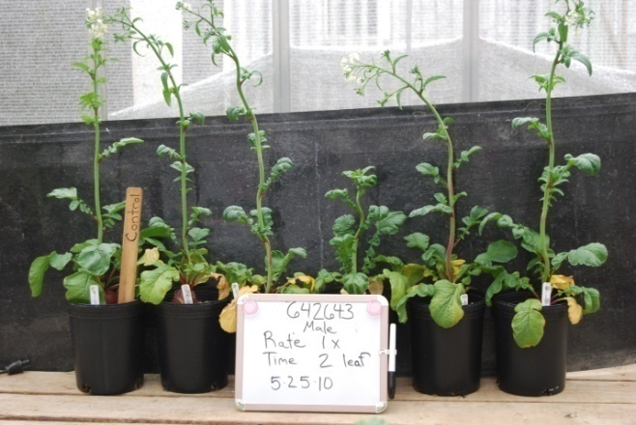 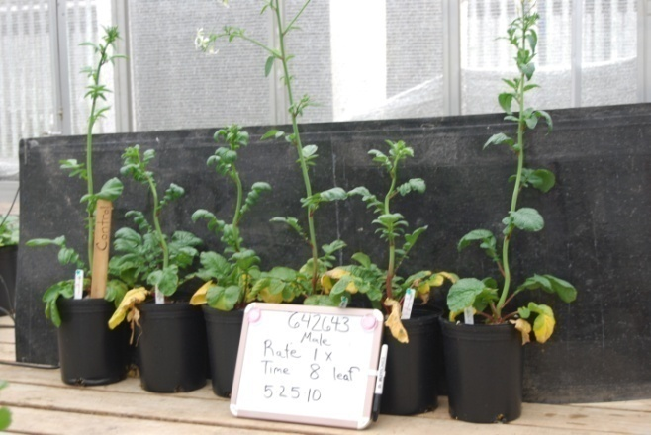

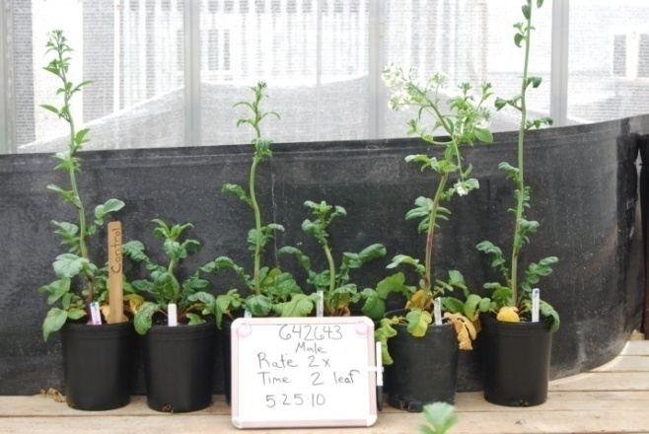 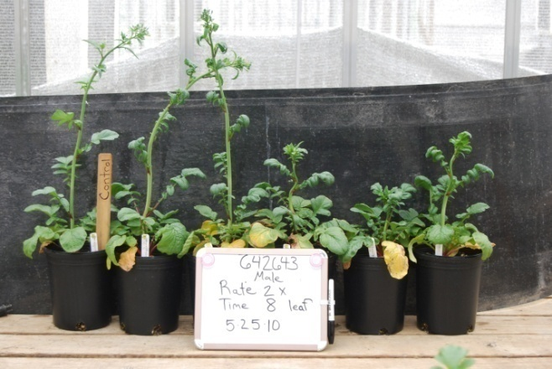

Figure 1. Radish var. 642643 tolerance to clopyralid applied EPOST, LPOST and at 2 rates. Note the check plant on the left of each row of plants.



Figure 2. Effect of clopyralid rate and timing on seed germination in 2010 averaged over the temperature range of 20 to 30C at 2.5C increments (var.RF-17MS) (+SE).